LINGAYA VIDYAPEETH

Topic-Basic of Accounting
Principle

Objective of
Assignment
The main objective of the
assignment
is to develop a understanding of the basic principles of accountings in business entity.
Accounting Principles.
Accounting concept
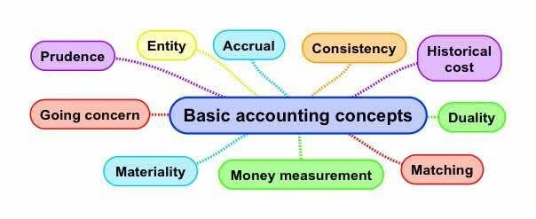
Accounting concept are the rules that help in operations run the business smooth.
1.Going concern concept: this concept considered that business will continue to exit for a long period in a future.
2. Consistency concept: this concept state that accounting principles and method should remains consistent in future.
3.Accrual concept: this state that revenue is record when service are renders.
4.Business entity concept: in this business is treated separate legal entity distinct from it owner.
- Money Major Concept: in this only those event and transactions are record which a major in terms of money.
- Accounting Period Concept: as per this the entire life of the firm is divided into small intervals. Interval compromise of 12 month.
7.Cost Concept: according to this an asset is record in the book of account at it original cost.
8. Dual Aspect lConcept: every transaction effects at least two account first it debit and other its credit.

Accounting conventions
Accounting conventions are the general custom that every accountant must accept
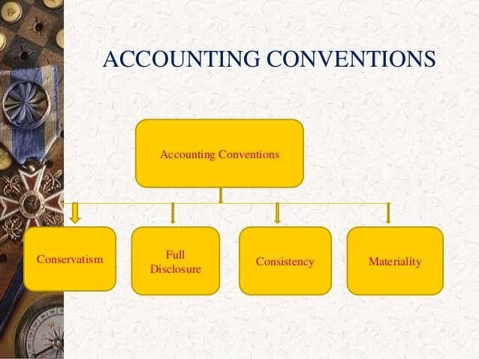
- Convention of Full Disclosure: this concept state that all the information will be record in the book of account.
- Convention of materiality: this state that all the important information must be record.
3.Convention of conservatism: distalis about all the anticipated lords are record in the book of account but all the future games will ignore.

